**Platform Engineering Assignment-3**

N.V. Nithin Kumar

1433832

1) Create and Configure an Azure SQL Database:

Step -1: Create a new Azure SQL Database.

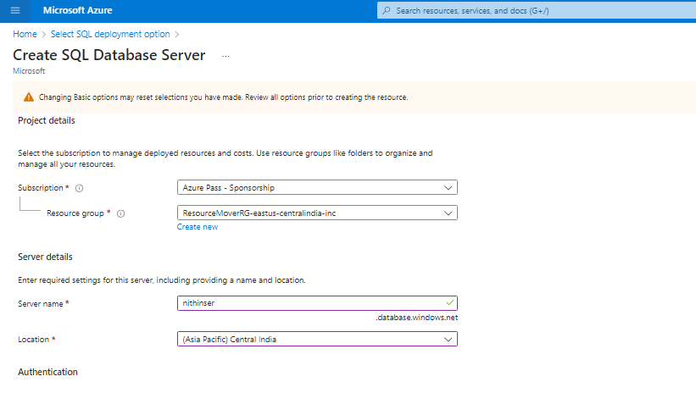

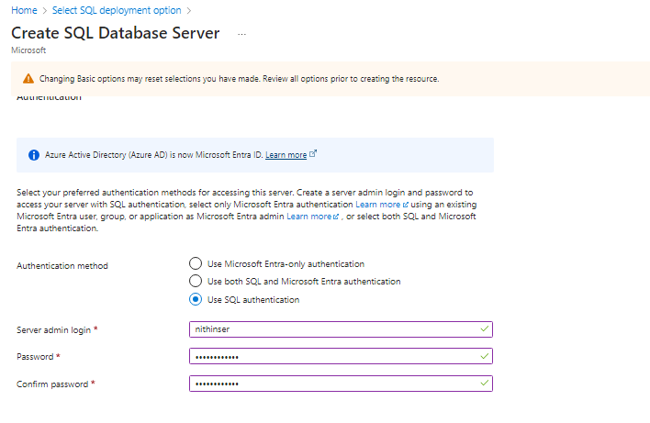

* Change the firewall rules to yes for allowing the IP adsress

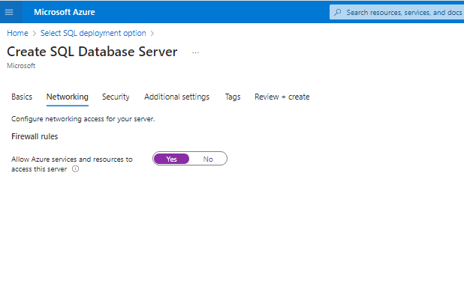

* Now click Review ad create.

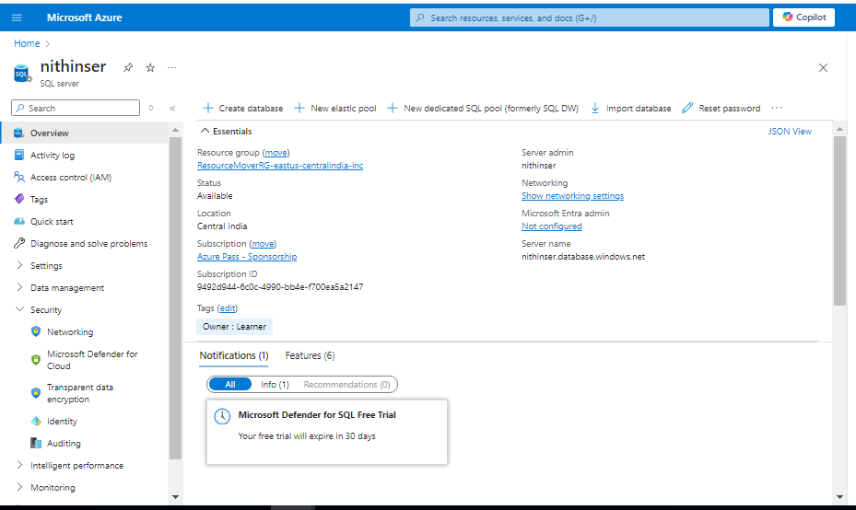

Step-2: Click on the create database and create one database with sample data.

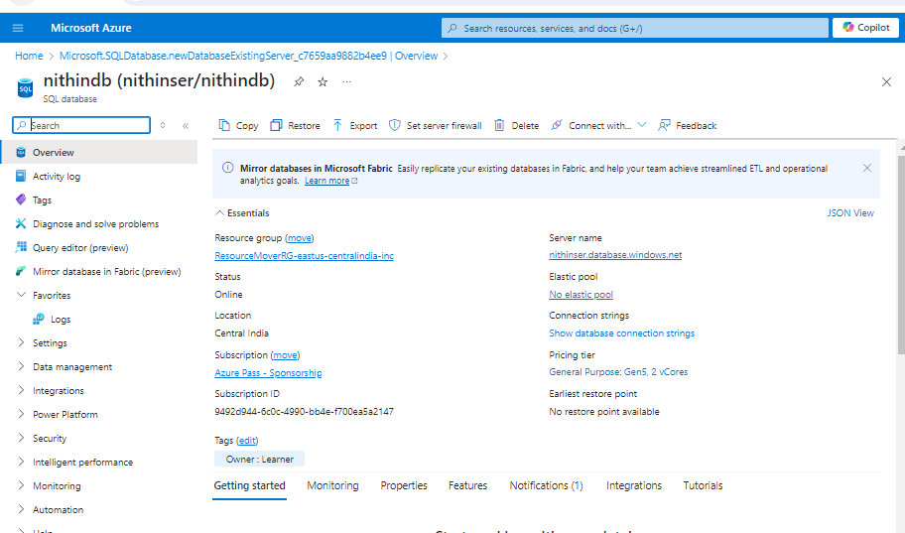

Step-3:After creation of DB login to it.

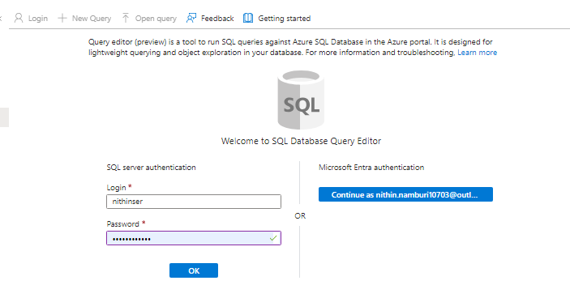

Step-4: Create tables, insert sample data, and run basic SQL queries.

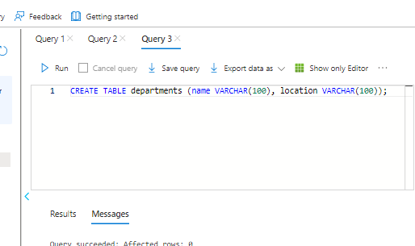

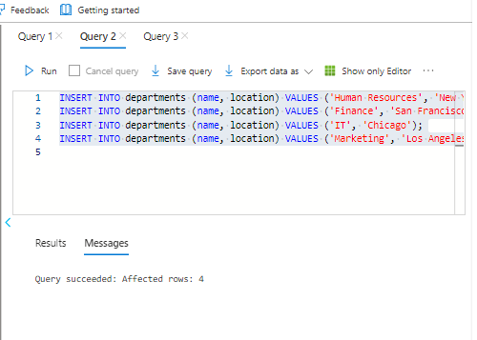

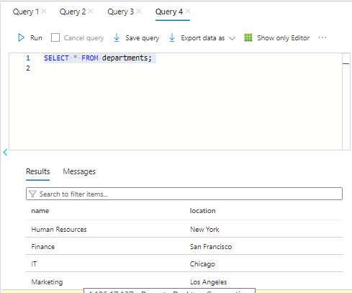

Step-5: Create Employees and Departments tables and demostorate INNER JOIN, LEFT OUTER JOIN and RIGHT OUTER JOIN.

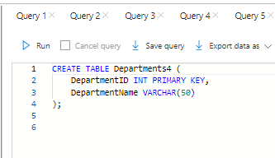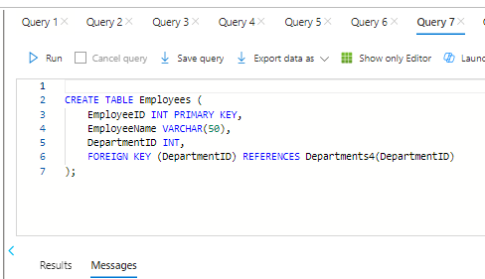

* Inner Join

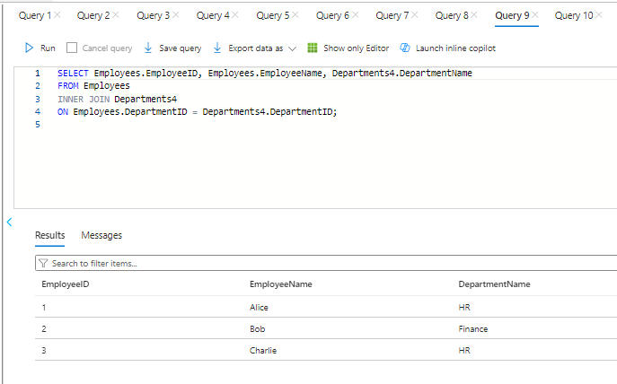

* Left Outer join

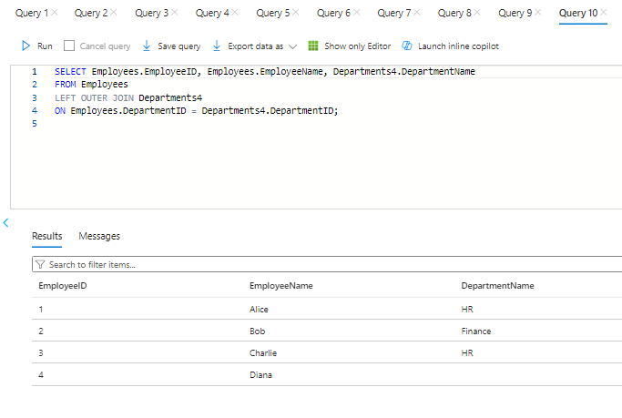

* Right outer join.

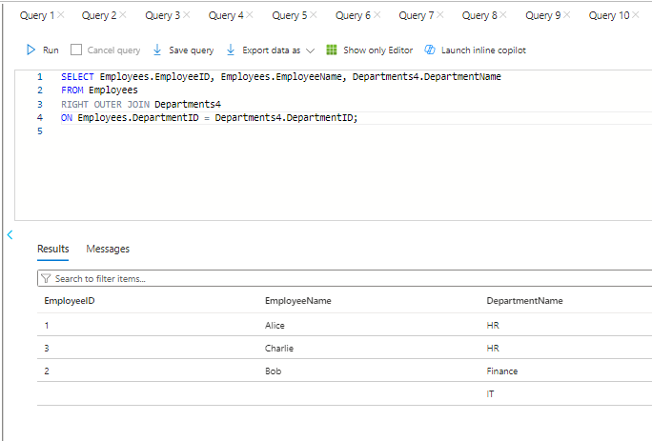

2) Create and Configure an Azure MYSQL Database.

Step-1: Create a new Azure SQL Database. 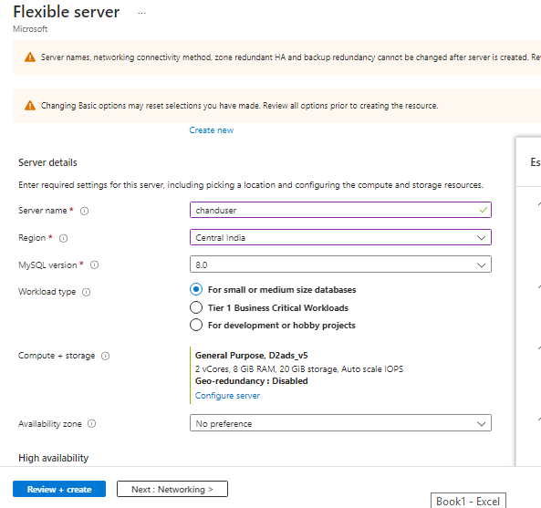

Step-2: In Networking setting change the firewall rules to allow the specific IP addresses. Configuring firewall rules to allow access to your database from specific IP addresses.

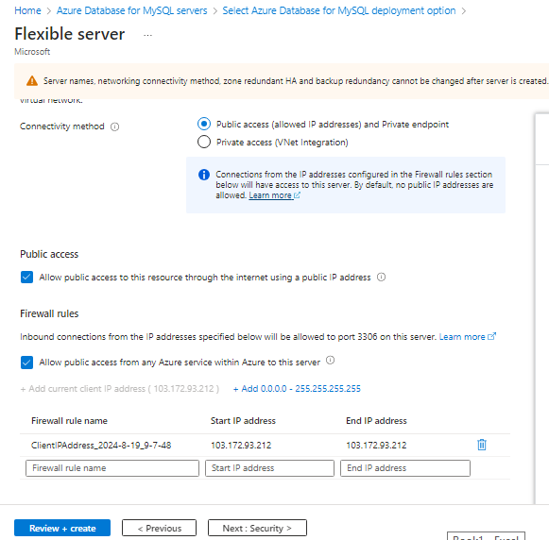

Step-3:Click on Review and create and go to the resource.

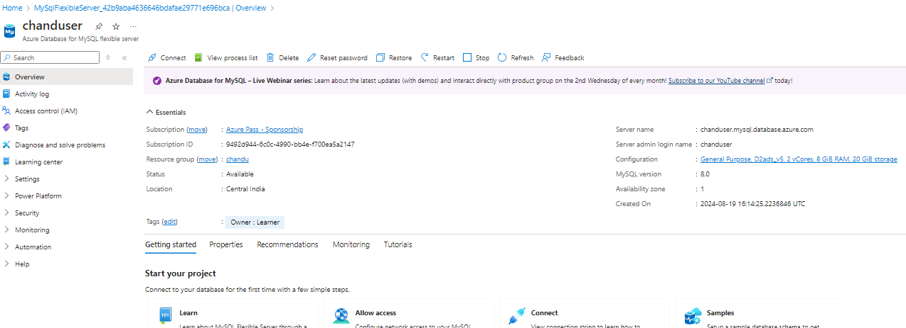

**Step-4 : Now open the Mysql workbench and create a new sql connection with the below details.**

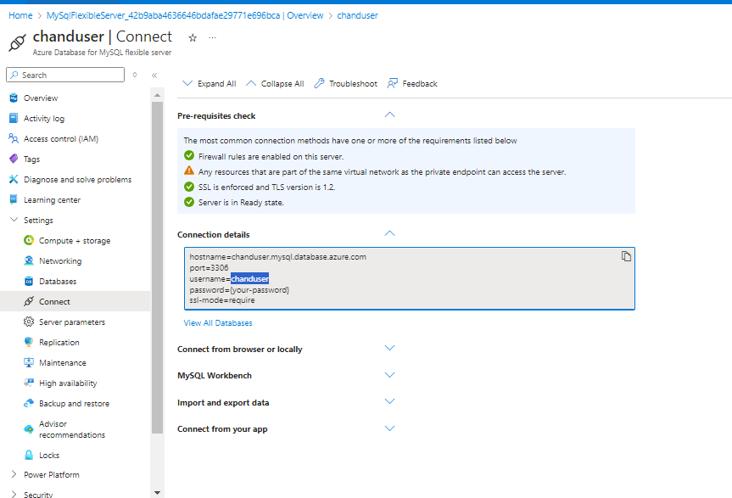

Step-5: Now click on the new SQL editor created.

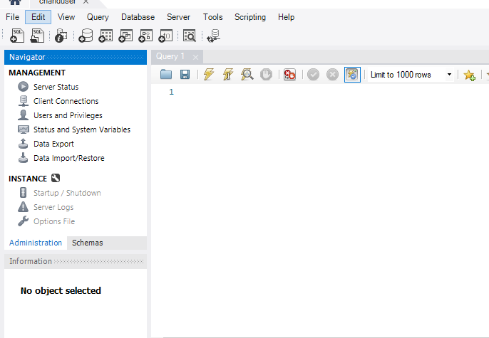

Step-6:Now you can perform the queries of your interest.

* Create tables, insert sample data, and run basic SQL queries.
* Created a table named products under the chandudb database and inserted data to it.

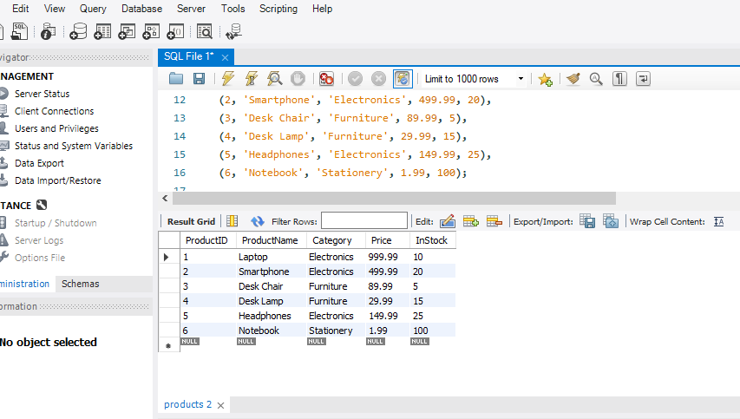

Step-7: Perform some queries on it.

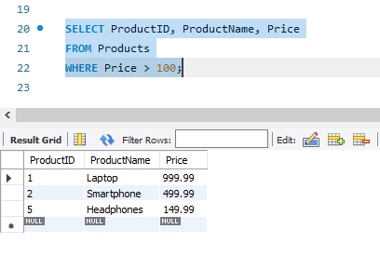

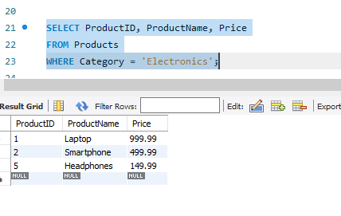

* Create Employees and Departments tables and demostorate INNER JOIN, LEFT OUTER JOIN and RIGHT OUTER JOIN.

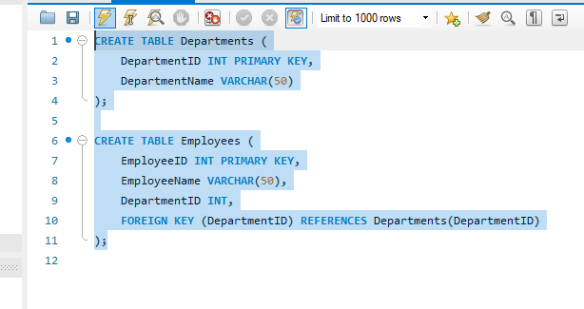

* Inner Join

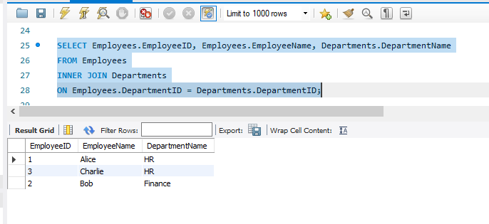

* Left Outer Join 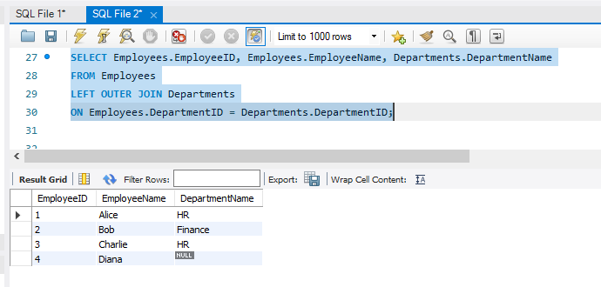
* Right Outer Join

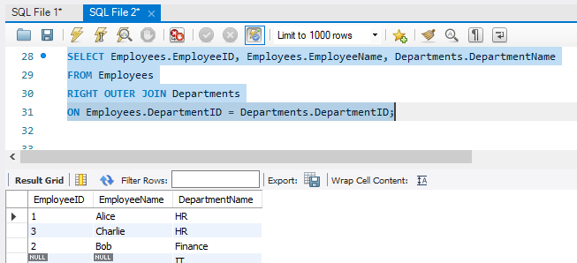

Step-8 : Configure automated backups and test restoring a database from a backup

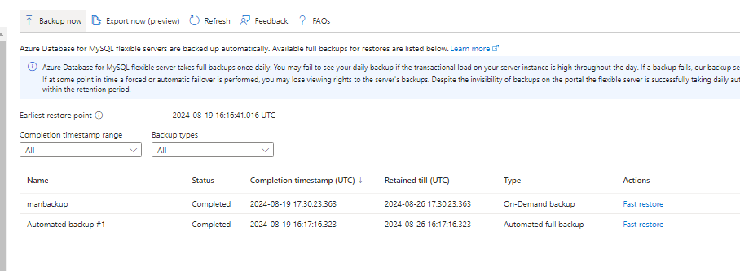

Step-9:Now we try to restore the intial backup.Go to settings and click on the backup and restore option and click fast restore on the oldest backup available.

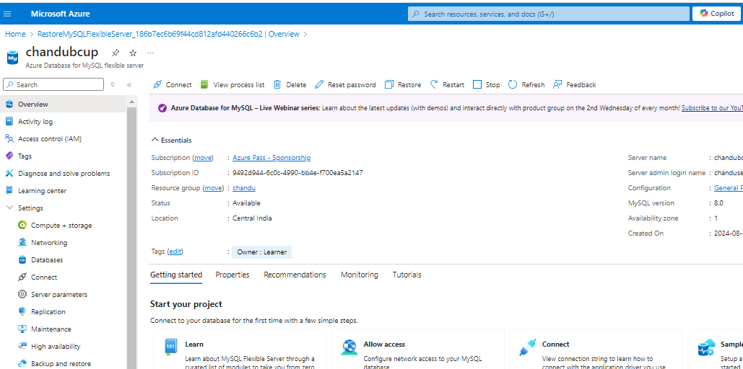

Now connect to the workbench for the backup database and check point of time backup.

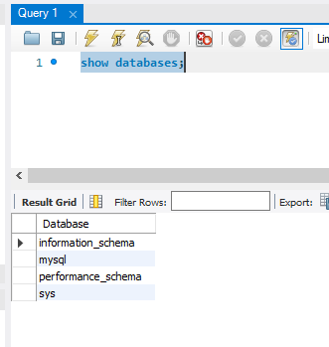

Step-10: Set up and configure geo-replication to create readable secondary replicas in different regions.

* For creating a replica go to the replication settings and click on the create replica.

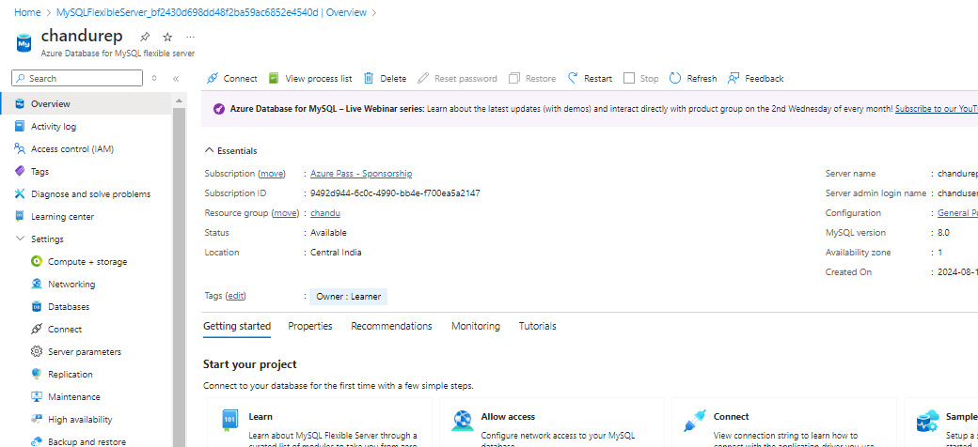

Open the replica SQL connection and then try to create or update anything.

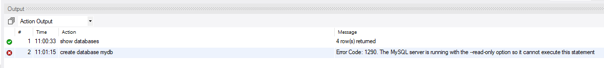

* We use replicas to only read the databases but not to manipulate the datbases.

3) Host a Jenkins image on azure container instance.

Ans)

Step-1: Create a Container instance.

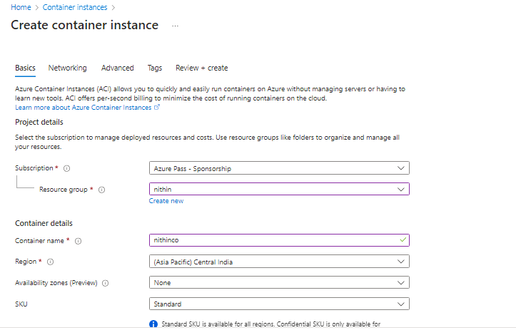

Step-2: On the basics page change the image resource to the other registry and configure the size to 2 cpu’s , 2GB memory.

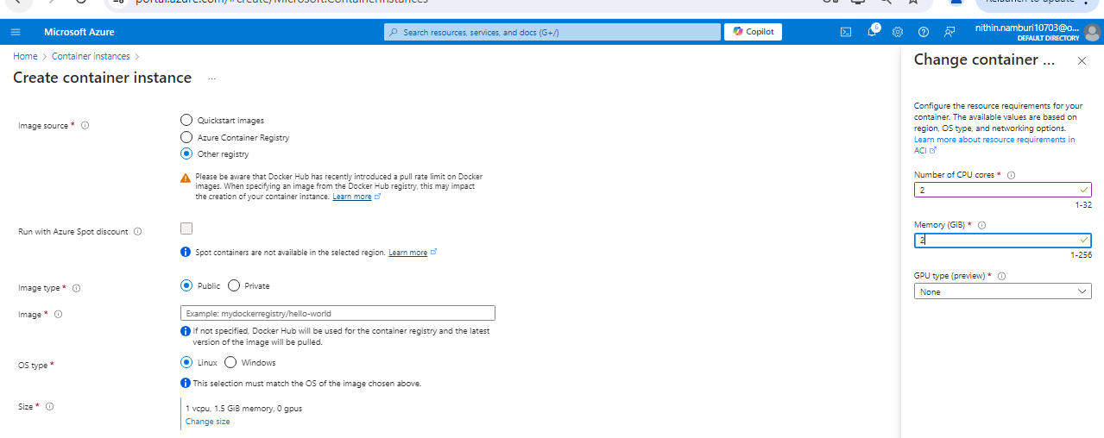

Step-3: Give the image path as jenkins/Jenkins it will automatically retrieve from the docker hub.

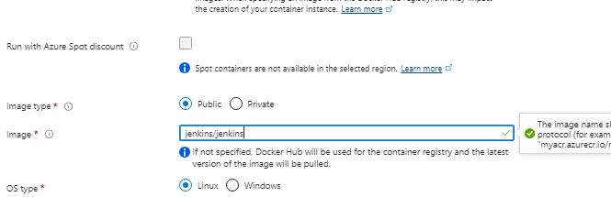

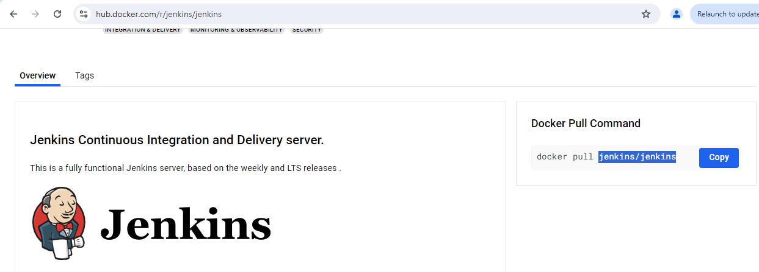

Step-4: Go to the network page and add the port number 8080 as TCP.

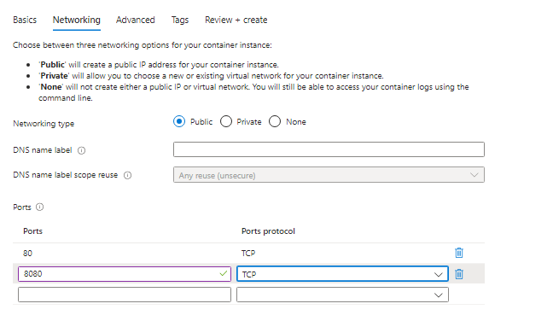

Step-5: Now click review and create.

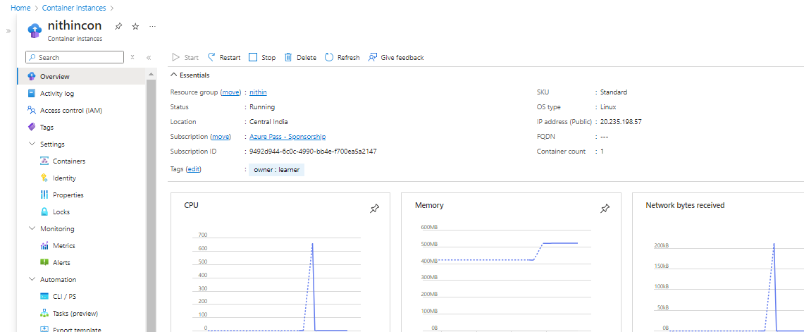

Step-6: Copy the IP address and check for the Instance.

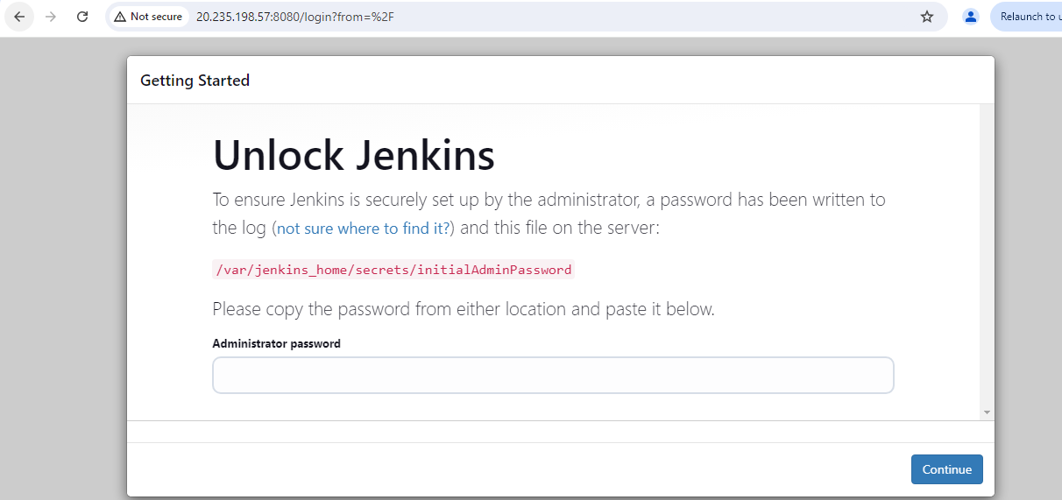

4) Create and Configure a Cosmos DB Account and demonstrate CRUD (Create, Read, Update, Delete) operations.

Ans)

Step-1: Create a cosmos Db account in azure with the location Central India.

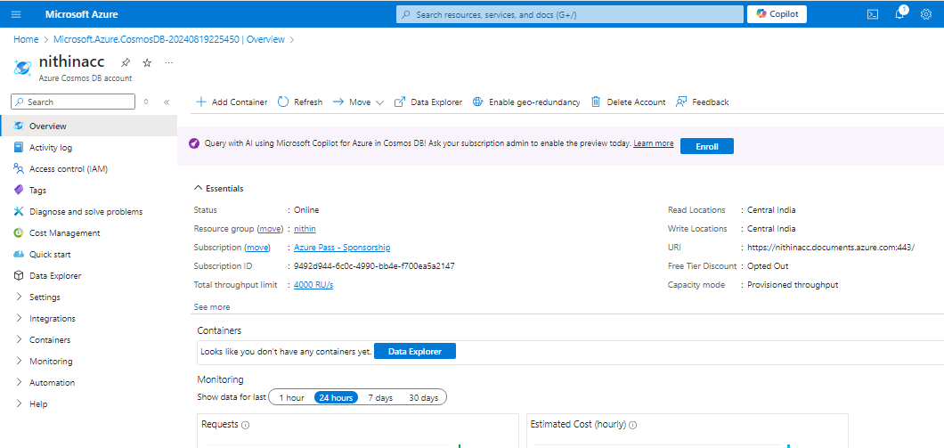

Step-2 : Goto Data explorer and click on create new container.

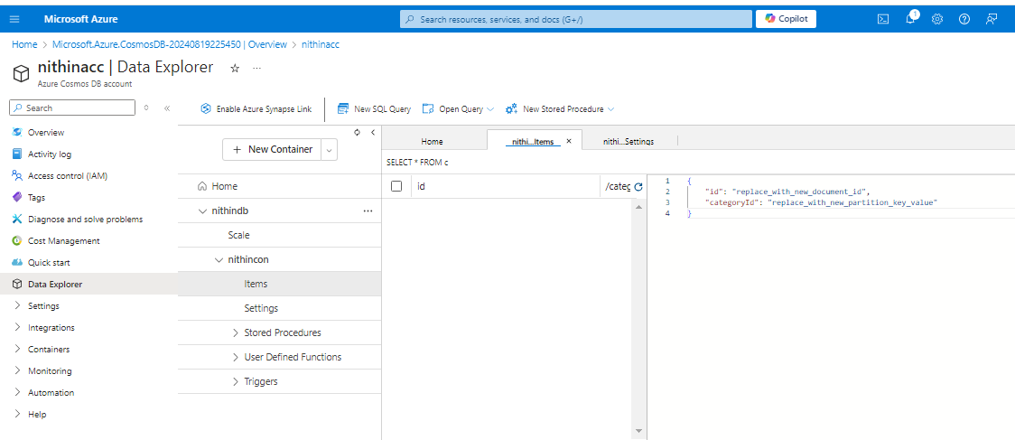

Step-3 : click on the new item in items setting and some data to it.

Create Operation:

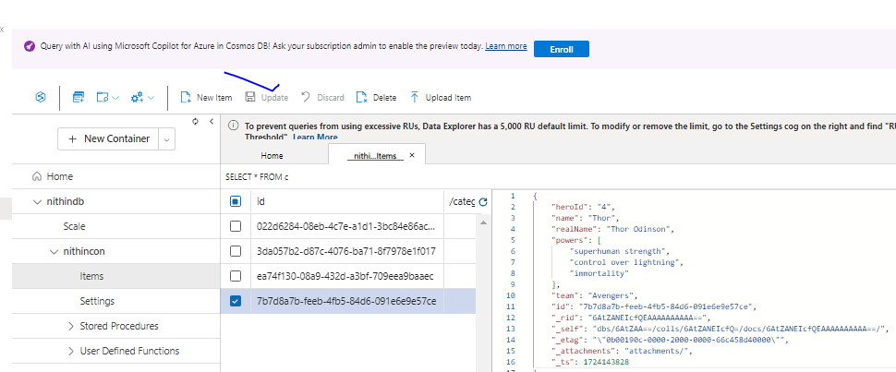

Read-Operation:

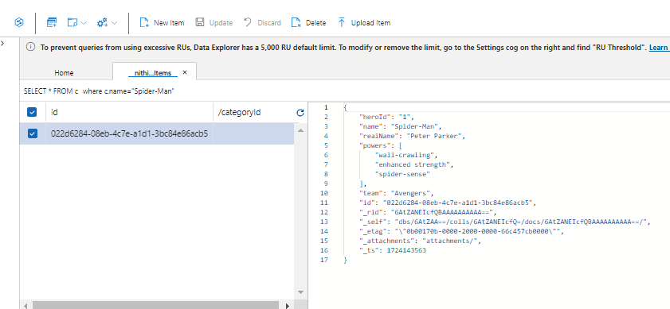

Update Operation: we updated the name from captain america to hulk.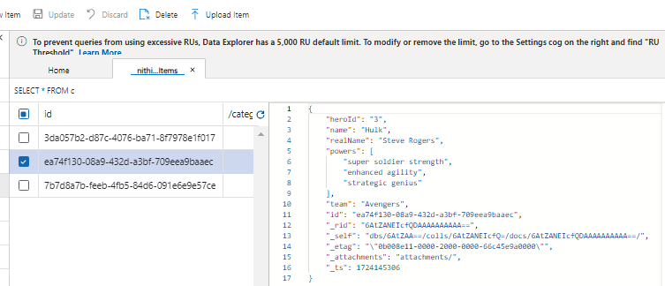

Delete Operation:  
before deletion: we have four rows.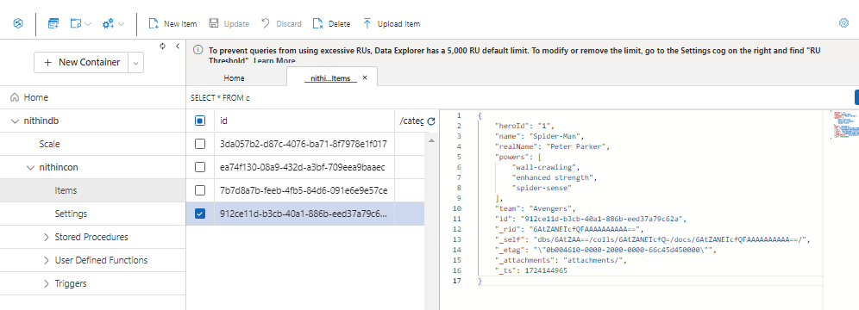

After deletion: we will have only three rows.

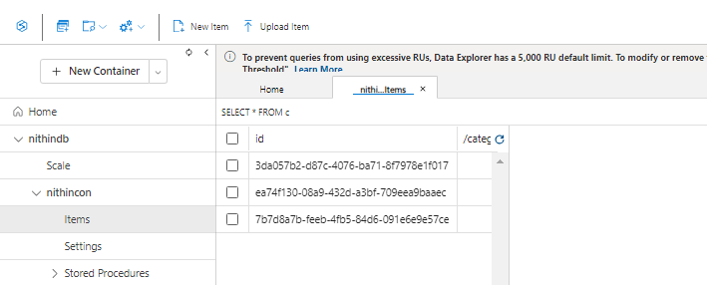

5) create alert for the high cpu usage with email notification on windows server.

Ans)

Step-1: Create a VM with windows as the image and change the size to the D2Sv3 and with enabling the alerts in the monitoring section.

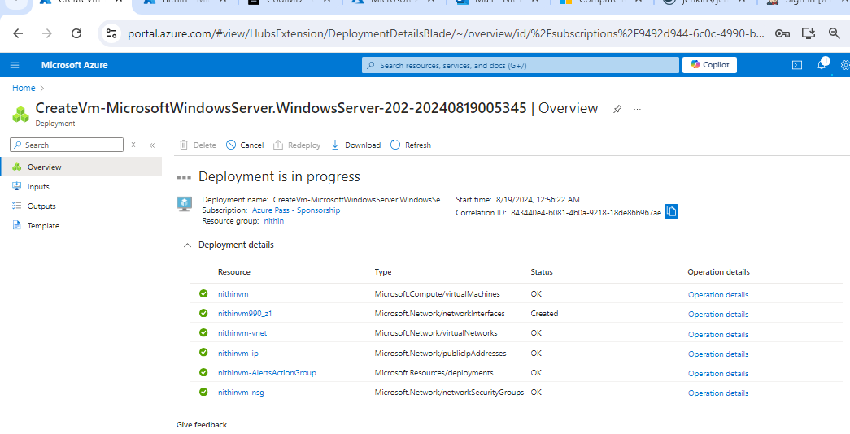

Step-2: Now connect the VM (IP address) to the RDP.

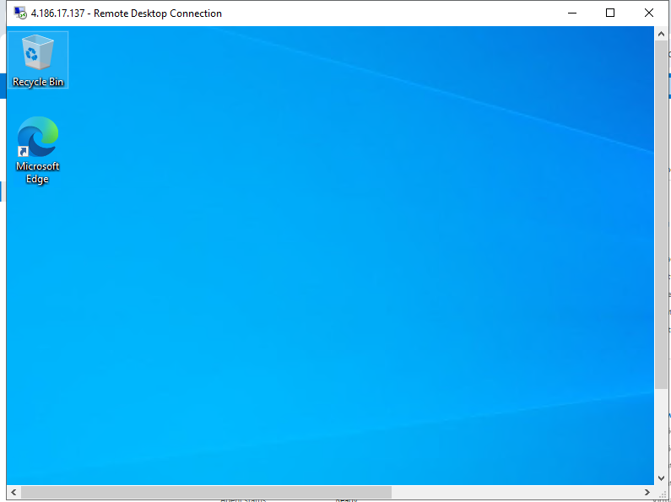

Step-3: Open the task manager and check for the CPU utilization.

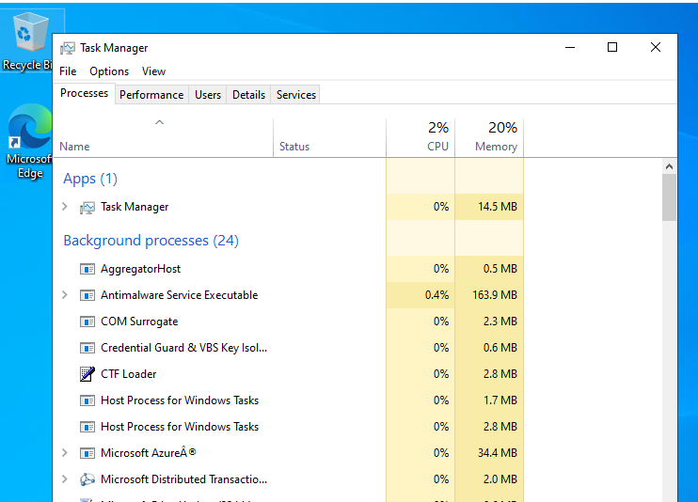

Step-4: go to the monitoring in the VM and set a metric for CPU percentage

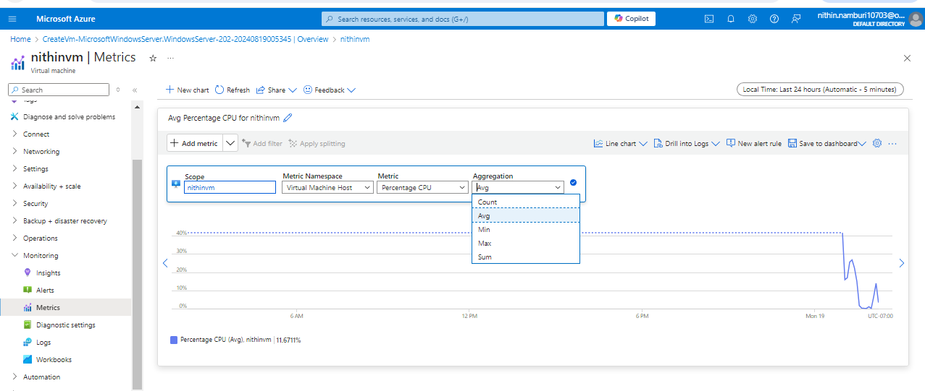

Step-5: Install a stress increasing tool in the RDP and maximize the stress.

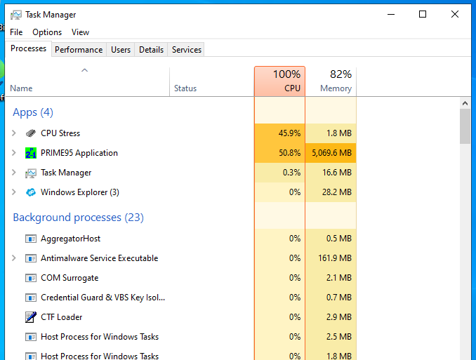

Step-6:Because we enabled the alerts options available in the monitoring we will get an email stating the CPU utilization is more.

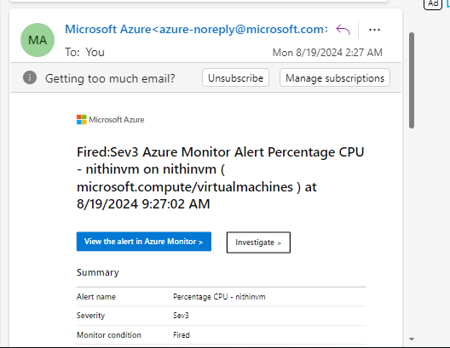

Step-7: Now check the CPU metric that you created in the VM it is also Increased than 80%.

